**Linux Assignment3**

**Ques:Create and compress the file with bzip2**

Touch filename

bzip2 filename

Or

bzip2 -z filename

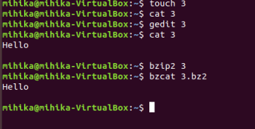

**Ques:What should be the argument to be given to unzip that file**

Unzip filename –d pathname

“-d” argument used to be given to unzip the file

**Ques: How to change the shell of user to “/bin/sh” at the time of adding the user.**

Run the following command:

